**NNFL EXPT-2**

**Fuzzy Controller**

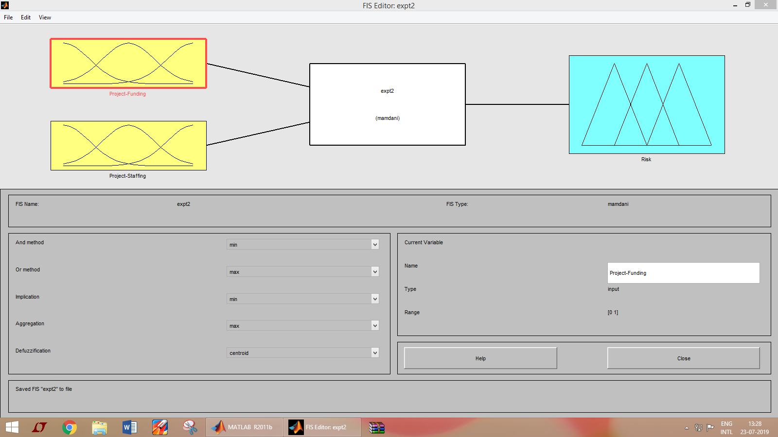

**Inputs :**

**Membership Function of Project Funding**

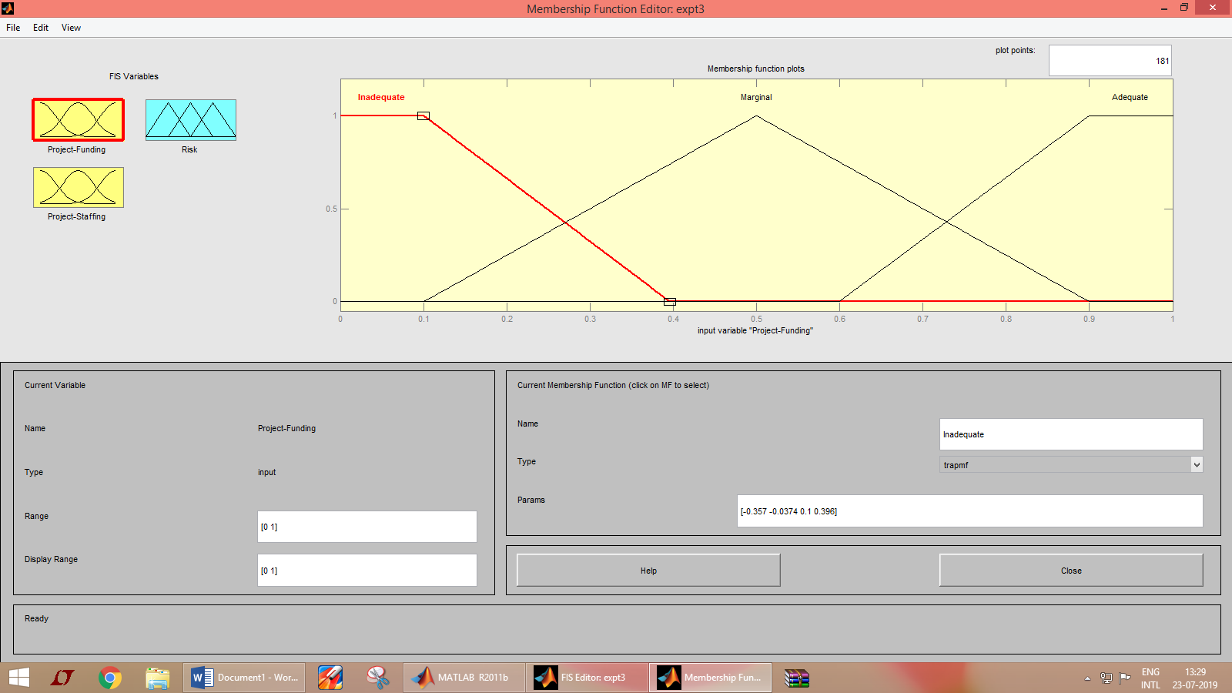

**Membership Function of Project Funding**

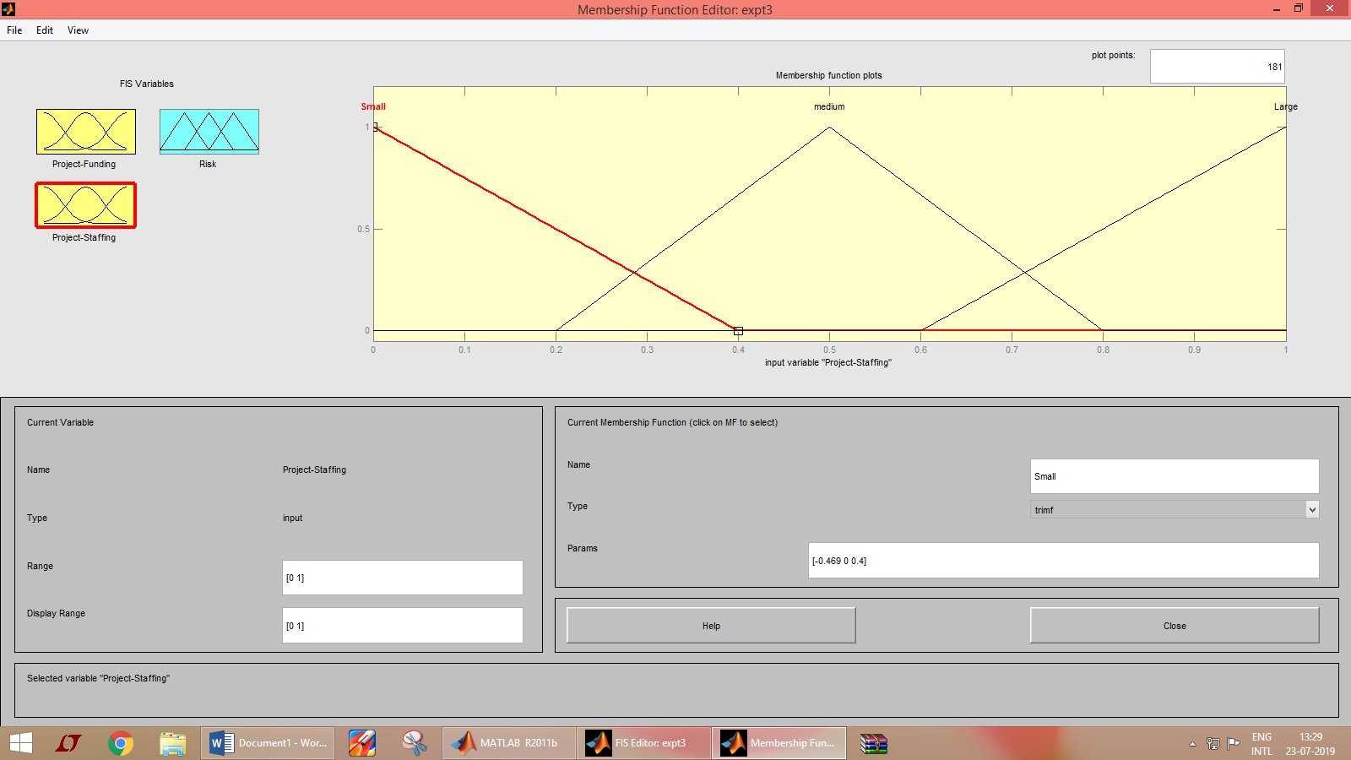

**Output :**

**Membership Function of Risk**

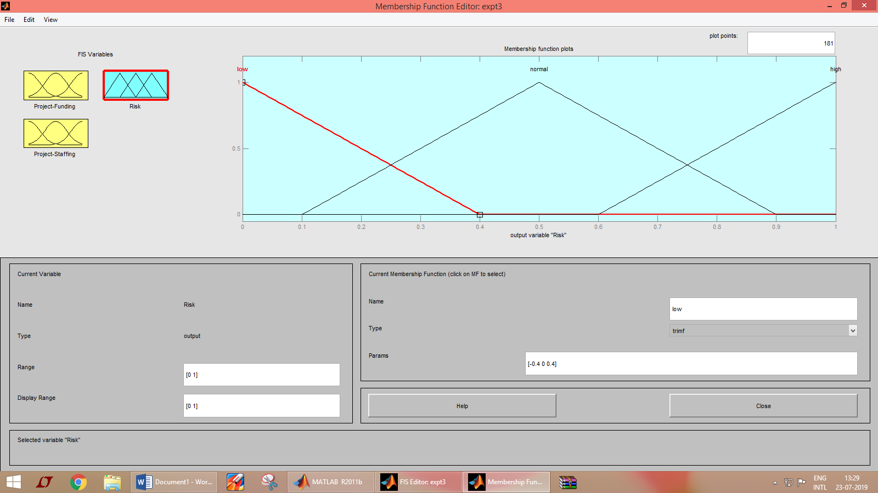

**Rules**

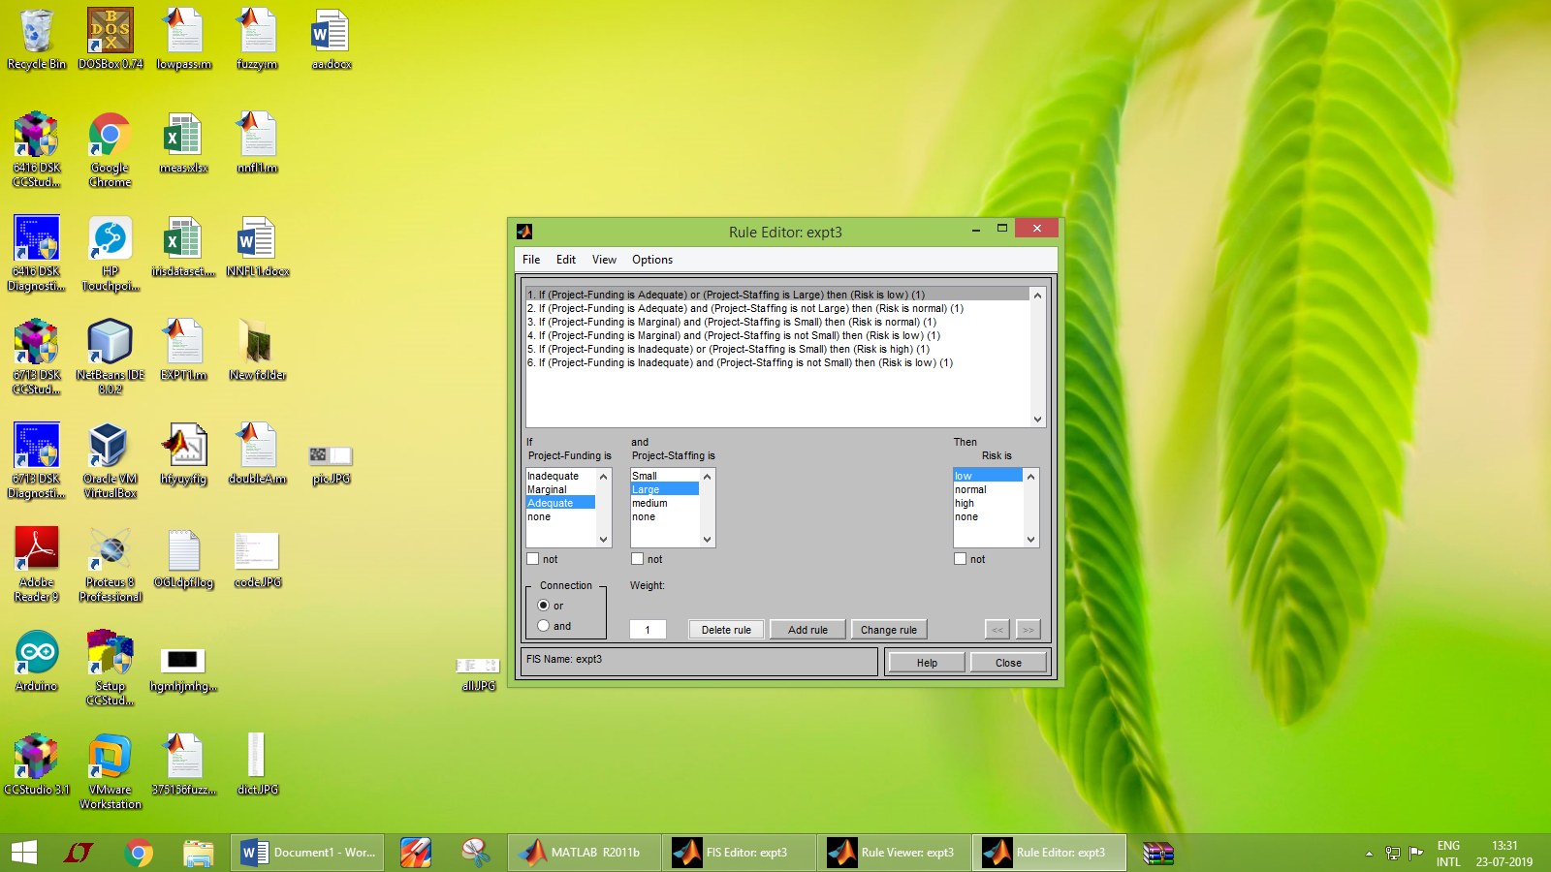

**Output : For High Funding and High Staffing**

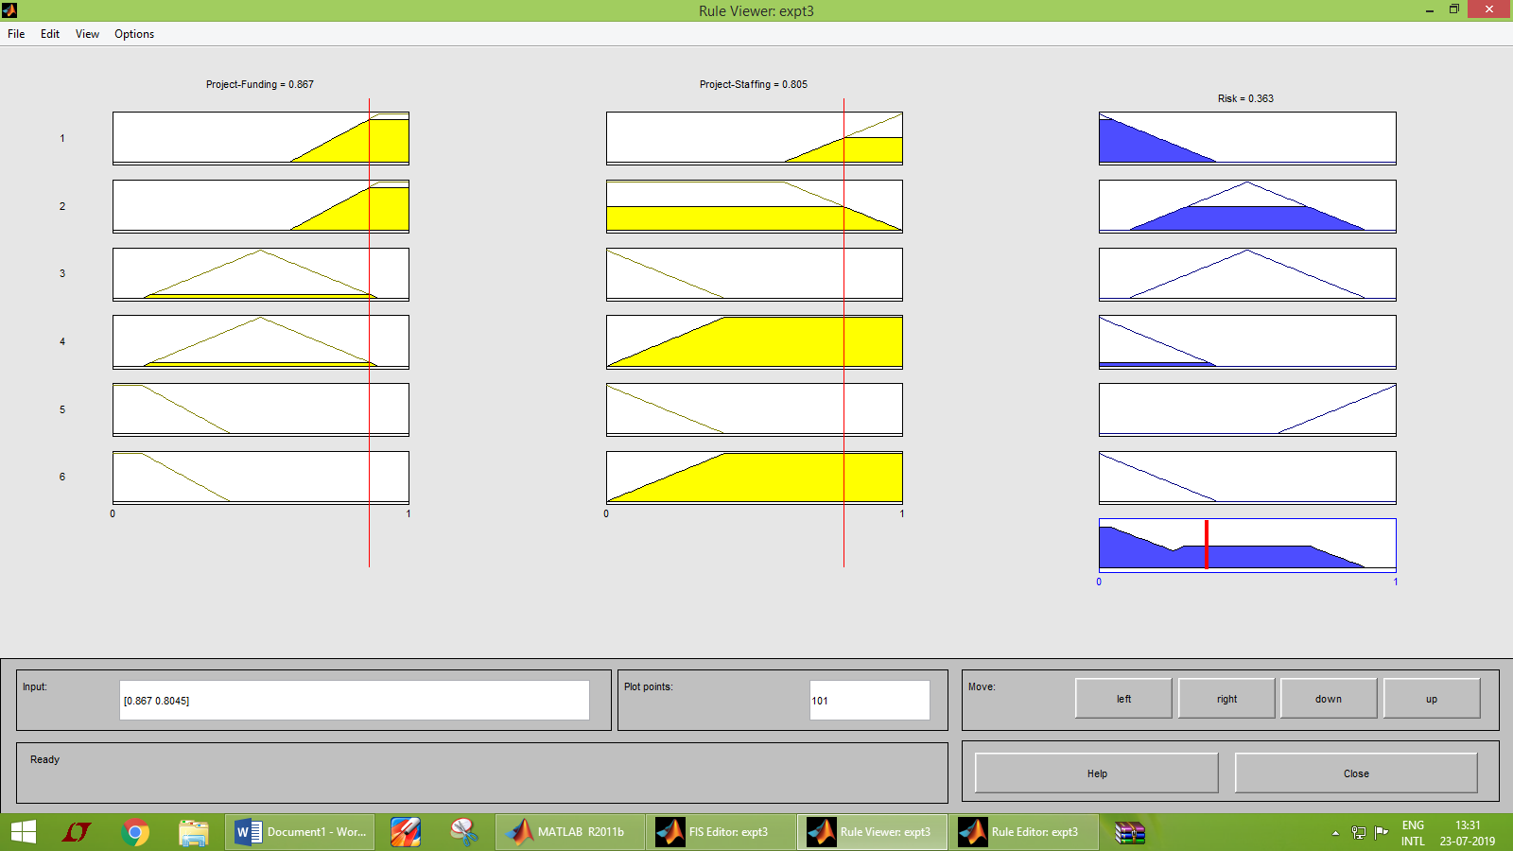

**Surface Viewer**

